Lab Exercise 3

IT4030 - Internet of Things (IoT) 2024

Lab 3: Using a Light Dependent Resistor (LDR) with an Arduino
Objectives:
- Studying about the Ohm’s Law, resistors, and voltage divider rule
- Creating a circuit in Tinkercad to get the readings from the Light Dependent Resistor (LDR) using the Arduino
Background:
Ohm’s law states that the voltage across a conductor is directly proportional to the current flowing through it, provided all physical conditions and temperature remain constant. The mathematical equation that describes this relationship is as follows.
𝑽 = 𝑰 𝑹
V = Voltage (V)

I = Current (A)

B
Sc in
Information Technology

Year 4
-

Semester 1
/2

R = Resistance (𝞨)

A resistor is a passive two-terminal electrical component that limits the current that flows through a circuit. The symbol of a resistor and resistors with different resistance values are shown in Figure 1 and Figure 2 respectively.

Figure 1: Symbol of a resistor
Figure 2: Different resistors
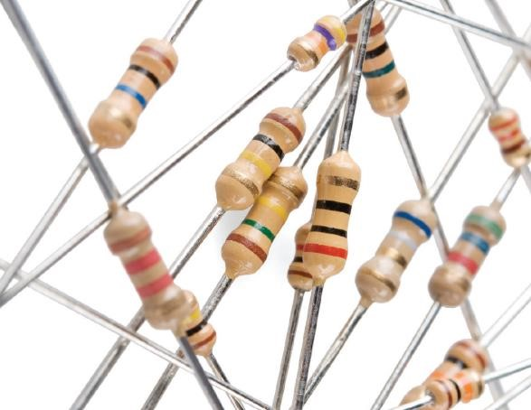
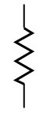
1

The resistor color code chart in Figure 3 shows how to determine the resistance and tolerance of the resistors. This can also be used to specify the color of the bands when the values are known.
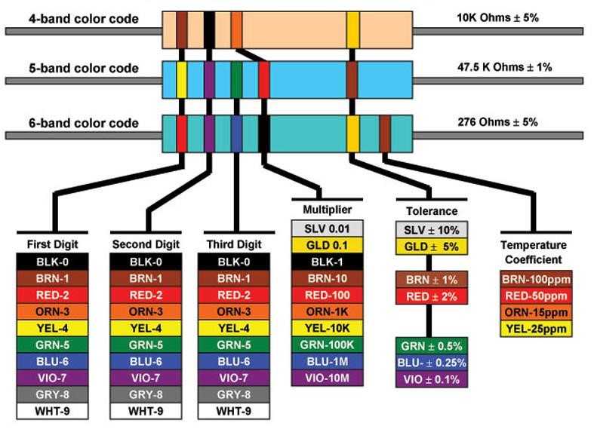

Figure 3: The resistor color code chart
In electronics, the voltage divider circuit (potential divider) which is depicted in Figure 4, is a passive linear circuit that produces an output voltage (V_{out}) as a fraction of its input voltage
(V_{in}).

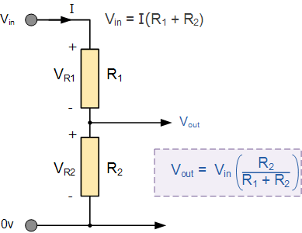
Figure 4: Voltage divider circuit

A Light Dependent Resistor (LDR) which is also known as a photoresistor is a passive component that decreases its resistance with respect to the luminosity (light) that falls onto the component's sensitive surface. An LDR is shown in Figure 5.
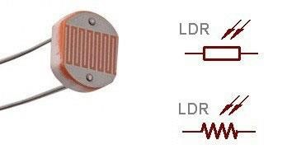

Figure 5: An LDR

Procedure:
- Using Tinkercad, create the following circuit to get the readings from an LDR using the Arduino.
Circuit
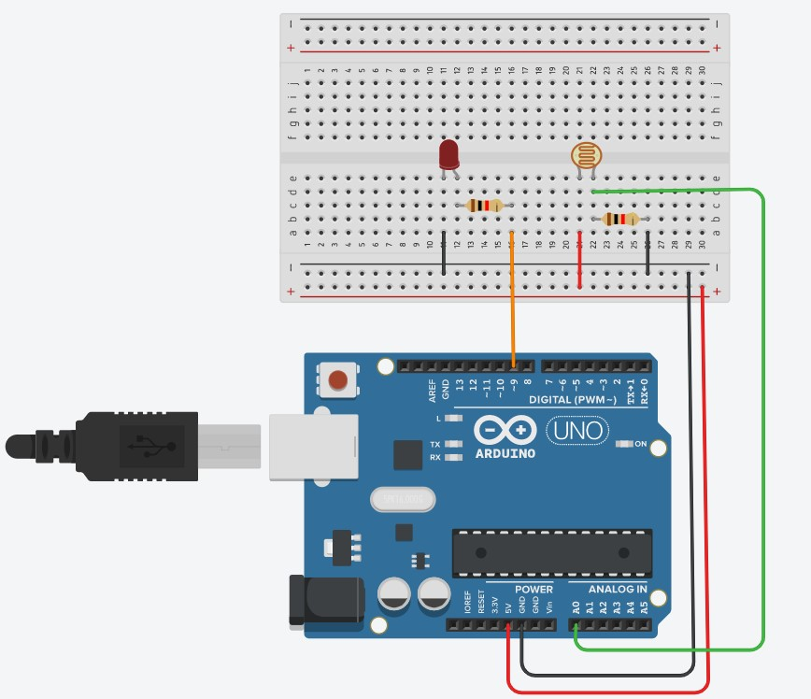

Code
int value = 0;
void setup()
{
pinMode(A0, INPUT);
pinMode(9, OUTPUT);
Serial.begin(9600);
}
void loop()
{
// read the value from the LDR
value = analogRead(A0);
// print the LDR reading
Serial.println(value);
// map the reading to a range for the LED
analogWrite(9, map(value, 0, 1023, 0, 255));
delay(100); // Wait for 100 millisecond(s)
}

Video

